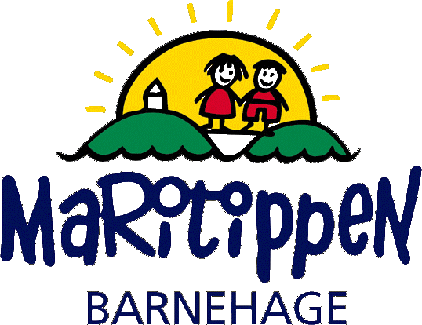
START UP CONVERSATION AT MARITIPPEN KINDERGARTEN
Welcome!
For us to be able to give your child the best care, we want to get to know your child and your family. Parental collaboration and dialogue are two critical factors for us to be able to meet the needs of each individual child. Therefore, we have a few topics we would like to discuss in this conversation. Responding to these questions are of course voluntary.
The following topics in the start- up conversation:
- The initial visit and understanding the child as an individual.
- Family and support network
- Everyday life, daily routines, interactions and language dynamics within the family.
- Physical and mental health
- Expectations to the kindergarten
Signatures required:
I consent that given information, follows the child when transitioning to a different department in the same kindergarten YES/NO
Parent- kindergarten teacher conference, observations and health records are safely secured in the child’s personal file. Only personnel in that department have access to the files.
Documents related to external authorities are only accessible to the general manager and the assistant manager. These documents are safely secured in locked cabinets.

Date and time of the conversation: | The child’s name, language/nationality:
Date of birth: | Present during the conversation:
Mother’s name, language/nationality: | Father’s name, language/nationality:
Siblings, name and age:

DESCRIPTION OF THE CHILD IN GENERAL:
How would you describe your child?
- Who is she/he? Can you describe your child’s personality/behavior?
- What is her/his interests?
- How does your child express when they are happy, content, tired, hungry, in pain sad etc.?
- Is there any relevant information about your child’s eating habits, sleeping habits or activity level that we need to be made aware of?
- Is there anything about your child that worries you?
- Is there any information during pregnancy or during childbirth that might be relevant? Premature?
- Has she/he been to another kindergarten?
- If your child is not born in Norway, would you care to share a little bit about your country? Experiences?

FAMILY/ NETWORK:
Who lives with the child? (Who has daily care?)
- Are there any significant individuals in the child’s network such as grandparents, siblings or others?
- Do you have family nearby?
- Is your family in contact with other support services? (Family Center, Health Clinic, Educational Psychology Service (PPT), Child Welfare or others?)
- If the parents live separately, clarify whether they prefer joint or separate conversations.
- How is your custody and visitation plan if your child is in shared residency? (Refer to separate document)
- How did the child react to the parent’s separation?

EVERYDAY LIFE, INTERACTION AND LANGUAGE
What is a normal day for you and your family:
- What is important to you and your interaction together as a family?
- What to you do you enjoy doing together? Activities (reading, playing games, being outside, singing etc.)
- How do you establish boundaries for your child?
- What is important for you in your child’s upbringing? What are your key principles?
- How would you describe your child’s language? (If multilingual; describe their native language. Any language -related challenges like dyslexia, hearing impairment or a tight frenulum?
- Any significant traditions and/or dates that are important?

HEALTH
How are the child’s sleep and rest needs?
Diapers, toilet-training, food.
- What is their preferred food and do they have any allergies/intolerances?
See attached document.
- Has the child experienced any distressing incidents like; accidents, serious illnesses or deaths?
- What are your perspectives on their dietary habits and physical activity?

EXPECTATIONS
What are your expectations for the kindergarten?
- What is it important to you? Is there anything we should focus on, to support the child to the fullest in their daily life and development?
- Is there anything else, apart from what we have already discussed in this conversation, that the kindergarten should be made aware of?

If you have any further questions or concerns, please do not hesitate to initiate a new conversation or contact us via email or phone.
The parents have been informed about:
- Confidentiality (Barnehageloven §22)
- The obligation to provide information to the Child Welfare Services (Barnehageloven §22)
- Collaborating partners: PPT (Educational Psychology Service), Health Clinic, Family Center, Child Welfare Services, UIA (University of Agder) and schools.
- Inclusion of everyone involved (Alle med) TRAS (Tool for Assessment of Reading and Writing Skills) and our website.

Date: ____________________________
Educator: _________________________
Parent: ___________________________

